Guynes Daniel M (Contractor)

[Email address]

Abstract

This document will provide an overview of how the IRS Power Platform Team plans to operate Power Platform Pipelines as an additional automated tool to help instill governance across the Power Platform environment to assist in ensuring long-term health and modernization of the IRS Power Platform Environment. This is a subset of the Power Platform Governance documentation.

power platform Pipeline governance

IRS Operational Governance Guidelines

# Table of Contents

Table of Contents 1

Table of Figures 2

Document Revision History 3

References 3

Purpose 4

Summary 5

Objectives 6

Elements Of Governance 7

Operational Governance 9

Future State of Power Platform Governance 10

Appendix A: Pipeline API Process 11

# Table of Figures

Figure 1 11

# Document Revision History

|  |  |  |
| --- | --- | --- |
| Editor | Date Edited | Comments |
| Daniel Guynes (contractor) | 1.17.2025 | Initial document creation |
|  |  |  |
|  |  |  |

# References

|  |
| --- |
| Document or Site |
| IRS Power Platform Governance.docx |
|  |
|  |

# Purpose

The purpose of this document is to define the governing responsibilities and tasks to be performed by the Power Platform Team (PPT) to maintain a healthy, up to date Power Platform environment using Power Platform Pipelines. The document will provide details on how Pipelines are used within IRS and how governance is implemented throughout the Pipeline process.

In this document the Power Platform environment is meant to include Power Apps, Power Automate, and Power BI.

# Summary

Pipelines are provided by Microsoft through Power Platform Dynamics 365 Application extensions to provide an automated means of deploying Solutions between environments. Pipelines not only provide automation but can also provide extra levels of Governance that are easier automated than manually delivered.

# Manual Process

The

# Pipeline Process

The Power Platform Pipeline will consist of the following objects:

1. A single Pipeline Host environment
   1. Power Platform Pipelines Dynamics 365 application applied
2. Each Pipeline will consist of no less than (unless specific exceptions are made and documented)
   1. One Sandbox Environment (Sandbox)
   2. One Test Environment (Production – Managed)
   3. One Production Environment (Production – Managed)
3. Each Pipeline will consist of two Deployment Stages (unless specific exceptions are made and documented)
   1. Dev 🡪 Test
      1. From Sandbox to Test
   2. Test 🡪 Prod
      1. From Test to Production
      2. This process may only be done if the Dev 🡪 Test deployment has already successfully run.
4. Within each Deployment Request a Flow is run to intercept the deployment to validate the solution deployment request as follows:
   1. Is the deployment stage Dev 🡪 Test?
      1. (Yes) check to see if the version number is divisible by 5
         1. (Yes) Email is sent to the Pipeline Group notifying them of the requirements for deploying to production when the time comes.
         2. (No) Do nothing
         3. Allow deployment
      2. (No) Is the deployment stage Test 🡪 Prod?
         1. (Yes) Is the Solution Approved?
            1. (No) Deny deployment and send email to user to let them know why it was denied.
            2. (Yes) Deploy
         2. (No) Send Email to PPT with error message that something is wrong with the Deployment Stage name : Send Email to Pipeline Group that there was an error in the deployment and to contact the PPT.

# Governance Policies

The Pipeline process will follow the IRS Power Platform Team’s *IRS Power Platform Governance* document (see References). The Operational Objective is to provide an automated deployment capability to end users with fully integrated governance. This provides self-automation of development and deployment for end users, while also relieving the Power Platform team of daily or common deployment tasks.

## Governance Dashboard

You can use COE Starter Kit Power BI Dashboards to get an idea of current landscape of your Power Platform

## Environment Strategy

Guidelines for Creating Environments

Guidelines for Administration of Environments

Process for Requesting New Environments

Strategy for managing Teams Environments

Set up capacity soft limit for each environment

## Data Loss Prevention (DLP) Policies

Defining Connectors for each Environment

Process for defining newly created Environments DLP

Process to update existing DLP Policies safely without impacting end users

Process for Requesting New Connectors for Policies

## Security

Cross tenant isolation

Conditional Access Policies

Controlling Environment creation

Security groups for each environment

Process for requesting user access into QA/Prod

Strategy for managing guest user access

## License Management

Decide the License requirement to kick start your Power Platform Adoption

Define a process for the users to request new license

## App and Flow Management

Define App Classification criteria to decide which environment they will go to.

Set up App Compliance Process

Set up Inactive App/Flow Management Process

Set up orphaned App/Flow Management process

Define process for requesting new Enterprise App, promote an App to a different environment

## Application Lifecycle Management

Define your Application Lifecycle Management Strategy

## Monitoring and Analytics

Monitor your Platform in a regular basis to make sure nothing is going beyond as expected

Process for Setting up Auditing

## Developer Guidance, Upskilling, Communication and Support Plan

Create Developer guideline document with standards and best practices. Set up training sessions if needed.

Create a website with all Power Platform quick reference materials

Create a support model for supporting both developers and end users

Have a plan for Administrative tasks

Communication Plan

# Operational Use Cases

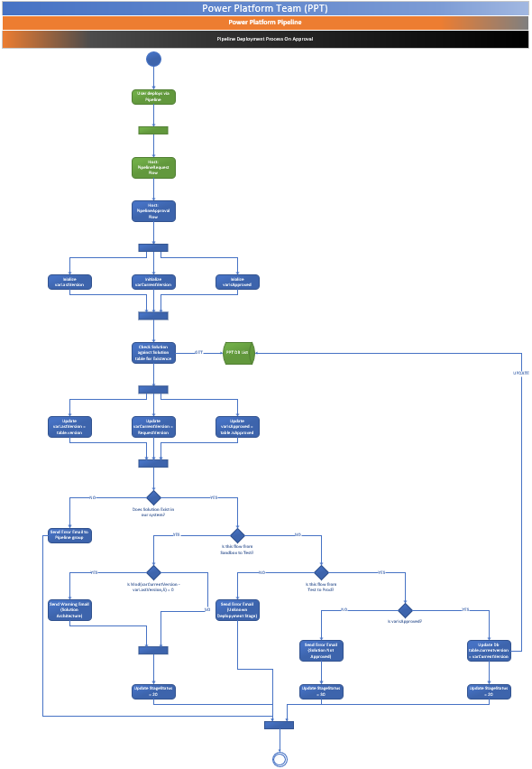

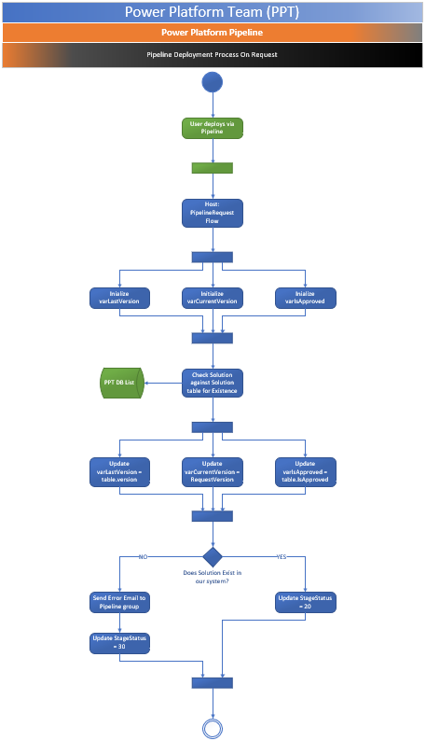

# Appendix A: Pipeline API Process

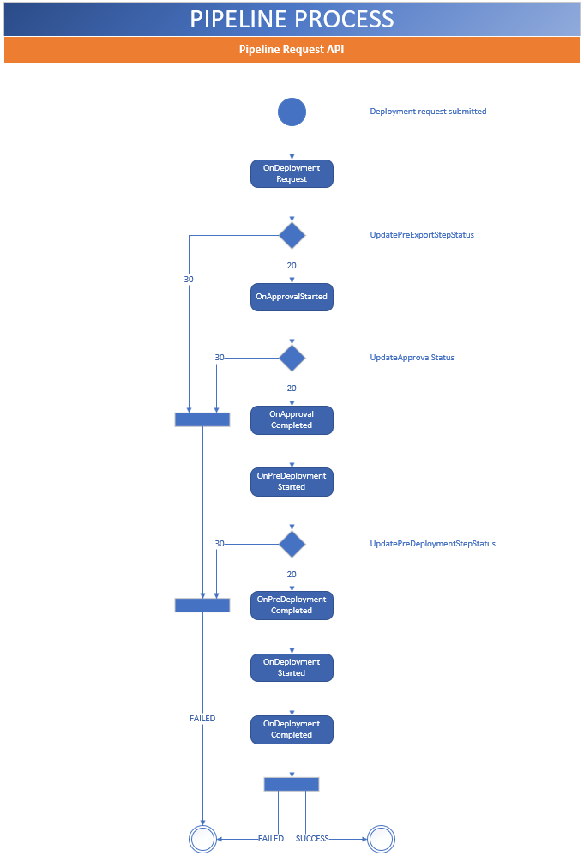

Figure 8

# Appendix B: Power Platform On Deployment Request Process



# Appendix C: Power Platform On Approval Process



power platform and power apps need to be under real governance

-how they are created

-how they are managed

-change in ownership?

-use case scenarios? easy/med/difficult

1. what are we doing for pipelines today

2. what are we not doing?

3. any needed contract support or tool we could use?

Who approves the actual apps? documentation?

Need responses to these questions by COB Wednesday next week.

What are we doing?

What are we not doing?- app checkers? reviews?

What are we planning to do?

Are there other tools that we can use to help provide governance?

What results are we trying to achieve?

What are the use cases?